SAX Parser

📦 What is a SAX Parser?
# Source: AI Source: Provided by: [Data Path: Persons Table -> ID Column: 1, Name_En Column: Motasem Essam] -> From: [Chatgpt (GPT‑5 Mini)] on [12/9/2025]
SAX stands for Simple API for XML. A SAX parser reads an XML file sequentially (line by line) and triggers events (like "start tag", "text", "end tag") as it encounters parts of the XML.

🔹 Key Concept:
# Source: AI Source: Provided by: [Data Path: Persons Table -> ID Column: 1, Name_En Column: Motasem Essam] -> From: [Chatgpt (GPT‑5 Mini)] on [12/9/2025]
A SAX parser is a stream-based, event-driven XML parser that does not build a tree in memory. Instead, it reacts to parts of the document as it reads them.

📄 Example XML:
# Source: AI Source: Provided by: [Data Path: Persons Table -> ID Column: 1, Name_En Column: Motasem Essam] -> From: [Chatgpt (GPT‑5 Mini)] on [12/9/2025]
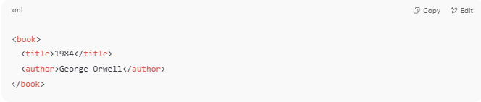
<book>
<title>1984</title>
<author>George Orwell</author>
</book>

A SAX parser will trigger events in this order:
- Start of <book>
- Start of <title>
- Text: "1984"
- End of <title>
- Start of <author>
- Text: "George Orwell"
- End of <author>
- End of <book>

🔧 How It Works
# Source: AI Source: Provided by: [Data Path: Persons Table -> ID Column: 1, Name_En Column: Motasem Essam] -> From: [Chatgpt (GPT‑5 Mini)] on [12/9/2025]
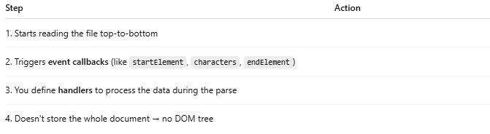
Step | Action
1. Starts reading the file top-to-bottom
2. Triggers event callbacks (like startElement, characters, endElement)
3. You define handlers to process the data during the parse
4. Doesn't store the whole document → no DOM tree

✅ Advantages of SAX
# Source: AI Source: Provided by: [Data Path: Persons Table -> ID Column: 1, Name_En Column: Motasem Essam] -> From: [Chatgpt (GPT‑5 Mini)] on [12/9/2025]
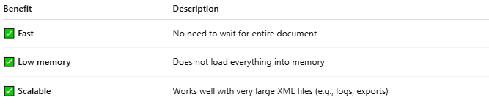
Benefit | Description
✅ Fast | No need to wait for entire document
✅ Low memory | Does not load everything into memory
✅ Scalable | Works well with very large XML files (e.g., logs, exports)

❌ Disadvantages of SAX
# Source: AI Source: Provided by: [Data Path: Persons Table -> ID Column: 1, Name_En Column: Motasem Essam] -> From: [Chatgpt (GPT‑5 Mini)] on [12/9/2025]
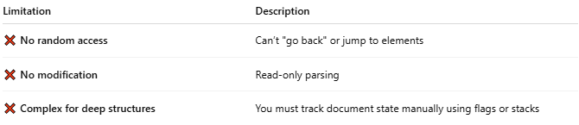
Limitation | Description
❌ No random access | Can’t "go back" or jump to elements
❌ No modification | Read-only parsing
❌ Complex for deep structures | You must track document state manually using flags or stacks

🧰 SAX Parser by Language
# Source: AI Source: Provided by: [Data Path: Persons Table -> ID Column: 1, Name_En Column: Motasem Essam] -> From: [Chatgpt (GPT‑5 Mini)] on [12/9/2025]
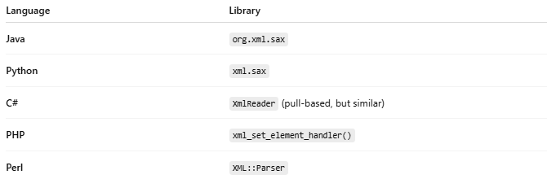
Language | Library
Java | org.xml.sax
Python | xml.sax
C# | XmlReader (pull-based, but similar)
PHP | xml_set_element_handler()
Perl | XML::Parser

🧪 Example: SAX in Python
# Source: AI Source: Provided by: [Data Path: Persons Table -> ID Column: 1, Name_En Column: Motasem Essam] -> From: [Chatgpt (GPT‑5 Mini)] on [12/9/2025]
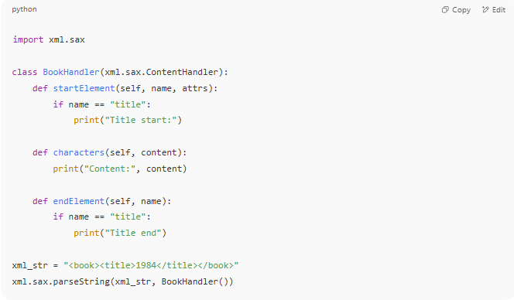
import xml.sax

class BookHandler(xml.sax.ContentHandler):
def startElement(self, name, attrs):
if name == "title":
print("Title start:")

def characters(self, content):
print("Content:", content)

def endElement(self, name):
if name == "title":
print("Title end")

xml_str = "<book><title>1984</title></book>"
xml.sax.parseString(xml_str, BookHandler())

🔁 SAX vs DOM Parser
# Source: AI Source: Provided by: [Data Path: Persons Table -> ID Column: 1, Name_En Column: Motasem Essam] -> From: [Chatgpt (GPT‑5 Mini)] on [12/9/2025]
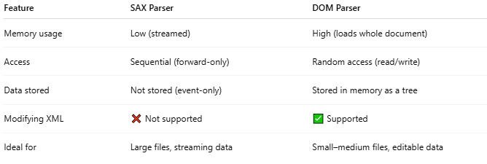
Feature | SAX Parser | DOM Parser
Memory usage | Low (streamed) | High (loads whole document)
Access | Sequential (forward-only) | Random access (read/write)
Data stored | Not stored (event-only) | Stored in memory as a tree
Modifying XML | ❌ Not supported | ✅ Supported
Ideal for | Large files, streaming data | Small–medium files, editable data

📌 Summary
# Source: AI Source: Provided by: [Data Path: Persons Table -> ID Column: 1, Name_En Column: Motasem Essam] -> From: [Chatgpt (GPT‑5 Mini)] on [12/9/2025]
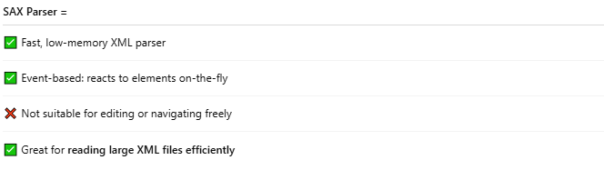
SAX Parser =
✅ Fast, low-memory XML parser
✅ Event-based: reacts to elements on-the-fly
❌ Not suitable for editing or navigating freely
✅ Great for reading large XML files efficiently

